Eric Refour

CSEE 4240 Wireless Sensor Networks

Final Project

Due: May 6, 2014

I. Introduction

Antarctica is one of the coldest, windiest, and driest continents on Earth, making it almost impossible for it to house any permanent human inhabitants. As a result of its extreme climate and regional isolation, Antarctica is one of the most untouched regions on earth. Although this makes the land of Antarctic highly valuable for numerous research fields, this same isolation and extreme climate also make it difficult for scientists to remain stationed in Antarctic to even conduct desired research and collect meaningful data. With tremendous efforts over the past years, scientists and geologists have made great discoveries in studying the land and atmosphere of Antarctica. These discoveries have ranged from unique fossils, minerals, and new species to even land discoveries. Some discoveries and findings have even revealed signs of potential changes in the future that could greatly impact life on Earth. Particularly, the interest of climate change remains a popular research focus in Antarctic along with environmental science, geology, astronomy, and marine biology.

Despite the great attempts to positively explore the unknown land of Antarctica, human interactions and modern technology have brought waste, overfishing, habitat destruction, and the potential of exploiting essential resources. These impacts are causing great concerns such as global warming, water and air pollution, and ozone destruction. As a result of the growing concerns, some efforts have been made to establish environment policies and treaties to protect Antarctica. However, the proposal of deploying mobile robotic systems in Antarctica may prove to be more efficient.

Deploying mobile robotic systems throughout Antarctica can not only perverse the environment and essential resources of Antarctica, but can also lift the burdens of humans traveling and the dangers of striving to survive in Antarctica during research trips. These robotic systems can collect value data during long periods of time that can be used to conduct essential research. For this project, the particular research of climate change and weather will be well suitable for a sensoring system to collect meaningful data over a period of time in regions of Antarctica.

II. Challenges

Developing a big sensor networks can impose a range of challenges and problems to overcome. Many of these problems come as a result of the different constraints and requirements imposed by the different sensors, microcontrollers, memory, and other equipments and devices being used in the design of the network. For this particular sensor network of deploying a wireless sensor system in Antarctica, the microcontroller devices that are being used are the Arduino boards, which use the ATmega328 family microcontrollers. The sensors being incorporated for this project are the Honeywell’s HIH4030 humidity sensors, the TMP36 temperature sensor, and the LS20031 GPS receiver module sensor. With each of these devices and sensors come certain power requirements and consumption constraints, data accuracy range, precision range, temperature operating constraints, and even communication difficulties.

For this scenario of having sensor devices stationed in Antarctica, one of the biggest challenges will the extreme temperature of the area. During the winters, Antarctica can have an average daily temperature of less than -34.4 Celsius (-30 degrees Fahrenheit). This can have a negative impact on the quality of our data since some of the sensor having an operating temperature range outside of harsh weather. The TMP36 temperature sensor can only operate in a temperature range of -40*C to +125*C, similar to be the both the Arduino Fio and HIH-4030 humidity sensor which cannot operate in temperature lower than -40 degrees Celsius. With Antarctica having an average temperature so close to -40 degrees Celsius, the quality of the data being produce by the sensors may not be as effective and true. In addition, the microcontroller may not be able to function properly as well. Other challenges may be a result of the physical regional isolation of Antarctica and the rest of the world. The extreme distance may play a huge role in Internet and other wireless communication issues.

Power and energy consumption may also serve as an obstacle for building such a sensor networks. Most of sensor nodes are expected to be battery operated in order to preserve the lifespan of having these sensors deployed throughout the region. Radio communication is generally the main consumption of the power.

III. System Design

The architecture and organization are very essential concepts for designing an effective sensor network. For this Antarctica Sensoring System, Arduino microcontrollers are used to serve as data processors and nodes for the sensors of this mobile sensor networks. For the communication protocols, XBee Series 2 radios are used to communicate between the different sensor nodes, other routers, and the Gateway device as well. The TMP36 sensors, HIH-4030 sensors, and the GPS receivers are all embedded and connected with the Ardunio boards to create the Sensor Nodes. The sensors are bread boarded out and mounted onto the Arduino boards where they can be inputted into the pins of the microcontrollers. The Sensor Nodes are completed with XBee radios to provide wireless communication to and from the Gateway device. An XBee coordinator is used as the Gateway device for the network. This Gateway device receives data from the different Sensor Nodes and access the Server to store readings into Database through Internet connection. For demonstration purposes, the XBee coordinator is connected to a laptop computer with Internet access.

The Gateway device runs a Java code that allows it to parse through all the received data packets access the Server PHP files to store the information in the Database accordingly. The Database for this project is structured with a total of 4 tables, LogSensorData, Mote_Info, Sensor_Models

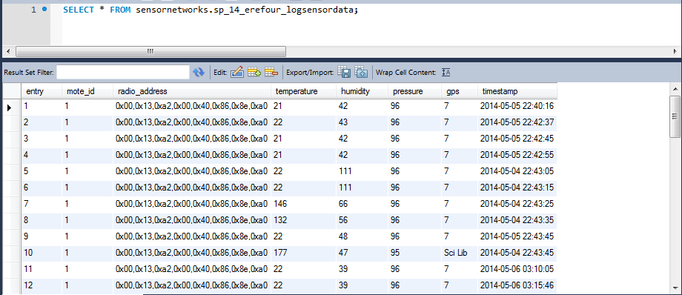

Record of sources

<http://www.discoveringantarctica.org.uk/>

<https://www.antarcticconnection.com/shopcontent.asp?type=science-environment>

<https://www.nsf.gov/funding/pgm_summ.jsp?pims_id=5519>

<http://sensornetworks.engr.uga.edu/w/index.php/Equipment>